Health and Safety Policy

AMENDMENTS

Last Review | Revision Description | Reviewed By | Date
May 2020 | The Health and Safety Policy has been updated as it is coming up to its annual review date. The main changes are; update of H&S structure, addition of the Fire Safety Sub Group and a new section on Risk Assessments. | Liz Dewell | 15/05/2020
May 2021 | Changed all references of Fire Safety Sub Group to Building Safety Sub Group, removed Learning and Development responsibilities for H&S training, added reference to HSG65 into the organisational arrangements sections and updated list of H&S related policies and procedures. Updated a section about how we will engage customers in health and safety matters | Liz Dewell | 04/05/2021
May 2022 | Changed all references of Audit & Risk Committee to Audit and Assurance Committee.  Changed all references from Company Leads to Managing Directors.  Updated the list of policies and procedures relating to H&S  Removed some responsibilities under the H&S BP.  Added in the new process of H&S sign off of all risk assessments.  Added GO Visits into auditing arrangements.  Added in the health cash plan and private health insurance programme | Liz Thompson | 17/05/2022

CONTENTS PAGE

GENERAL POLICY STATEMENT 4
STRUCTURE FOR THE ORGANISATION OF HEALTH AND SAFETY 5
ORGANISATIONAL ARRANGEMENTS 6
ORGANISATIONAL RESPONSIBILITIES 6
ARRANGEMENTS FOR IMPLEMENTATION 11
RISK ASSESSMENTS 12
TRAINING ARRANGEMENTS 12
MONITORING AND MEASURING PERFORMANCE 13
AUDITING AND REVIEWING PERFORMANCE 14
ENGAGING WITH CUSTOMERS 16
MENTAL HEALTH AND WELLBEING 16

GENERAL POLICY STATEMENT

The Boards of Directors, Chief Executive and the Executive Team for all companies that make up the Calico Group recognise their moral and legal duty to ensure, so far as is reasonably practicable, the health, safety and welfare of employees (including modern apprentices, temporary and agency workers) and others e.g. tenants, customers, volunteers, visitors, work experience students, contractors and members of the public, who may be affected by Calico work activities or attend Calico premises.
Furthermore, the Boards of Directors and Chief Executive will ensure that a process of reviewing performance of objectives is in place to drive continual improvement.

In order to minimise the risk of work-related injury or ill health, Calico will:
- comply with all relevant health and safety legislation but particularly: the Health and Safety at Work etc Act 1974, the Management of Health and Safety at Work Regulations 1999, the Regulatory Reform (Fire Safety) Order 2005 and the Construction (Design and Management) regulations 2015, by providing health and safety and other competent advice

- promote a positive health and safety culture by continuing interest in health and safety matters and by consulting and involving employees and their representatives

- provide adequate information, instruction, training and supervision to enable all employees to perform their work safely and efficiently

- provide and maintain appropriate equipment, safety devices, operational processes, safe systems of work and protective clothing

- provide appropriate arrangements for the safe handling and use of substances

- provide appropriate welfare facilities for all employees in line with legislation

- ensure suitable and sufficient risk assessments are carried out and reviewed on a regular basis

- ensure arrangements have been made for the effective planning, organisation, control, monitoring, and review of any procedure, control measures or preventative and protective measures identified through risk assessments or by other means

- provide appropriate health surveillance of employees as and when required

- carry out regular internal and external audits of the health and safety management system to ensure effectiveness of the arrangements and compliance with agreed standards

- compile leading and lagging KPIs to assist with the aim of continual improvement

- Calico will ensure that there is the necessary funding and resources available in order to meet the requirements of the health and safety policy, related procedures and operational processes.

Ring Stones have their own Health and Safety Policy due to the unique environment and specific legislation it operates under which covers its organisation and arrangements.
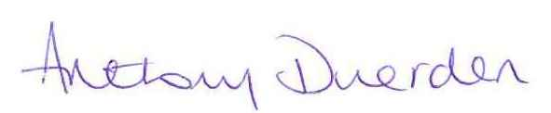

Anthony Duerden, Chief Executive

STRUCTURE FOR THE ORGANISATION OF HEALTH AND SAFETY

The Company recognises that health, safety and welfare are an inherent part of the business. For this reason the effective implementation of this policy will include the Boards, the Chief Executive, every Director and Company Lead, Managers, Supervisors and members of staff.

If a management level does not exist the next senior position in the line of management will ensure continuity for health and safety responsibility.

Calico’s Group structure is as follows:

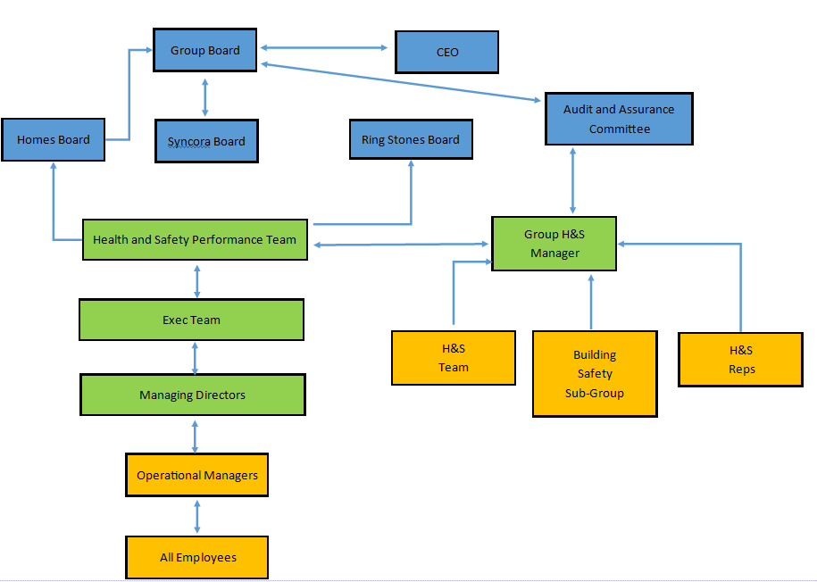

Each company within the Calico Group has their own Health and Safety Framework and Arrangements document detailing the local responsibilities for health and safety.

ORGANISATIONAL ARRANGEMENTS

The following diagram gives a representation of the safety management system that will be applied (based on HSG65).

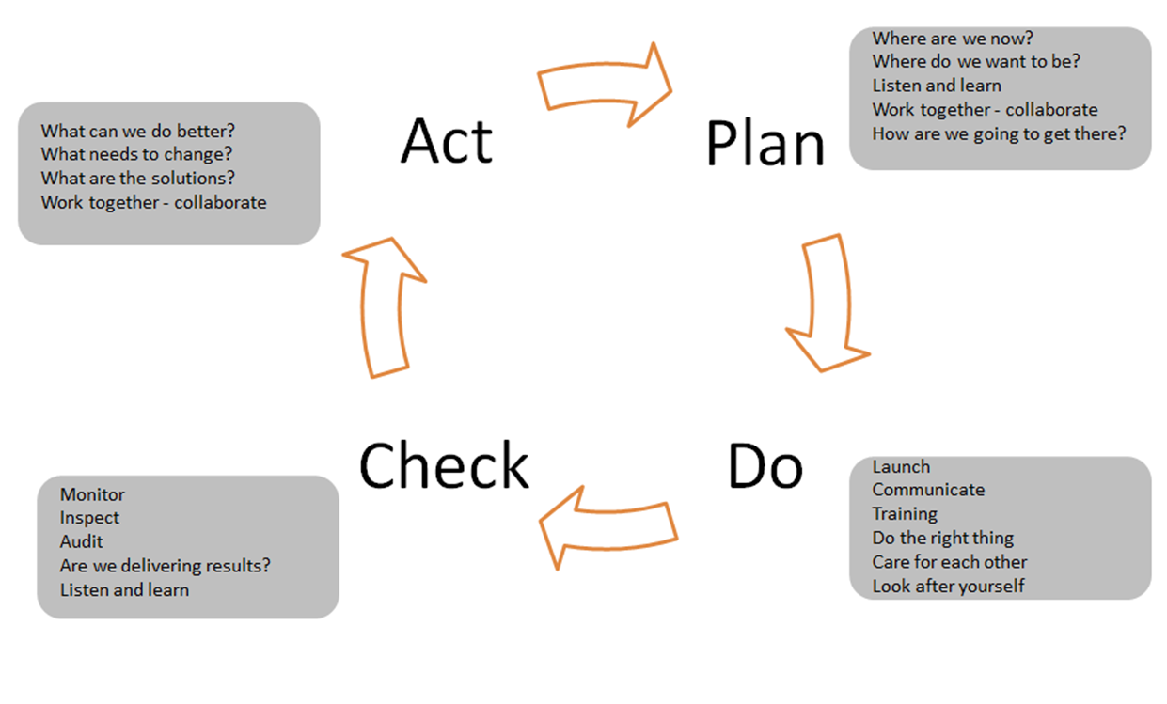

ORGANISATIONAL RESPONSIBILITIES

The Boards

Members serving on any of Calico’s Boards will ensure that appropriate arrangements are in place for:

Effective implementation of the requirements of the Health and Safety Policy and any supporting arrangements at all levels of the organisation
promoting a positive health and safety culture

In addition to ensuring that appropriate arrangements are in place for the above, members of the Calico Group Board will:

Ensure that an effective health and safety management system is in place
where appropriate, give guidance, instruction, recommendations and comment for the development of the Health and Safety Policy

Ensure that an annual review of the Health and Safety Policy takes place

Audit and Assurance Committee

In order to assist in carrying out its responsibilities, the Calico Group Board has established a Group Audit & Assurance Committee. The Audit & Assurance committee plays a key role in ensuring that the Group has an effective framework of internal control, including oversight of the internal audit function. The committee also receives assurance reports from each part of the Group confirming that legislation and regulation is monitored and the Group complies.

Chief Executive

The Chief Executive has overall responsibility for health and safety within Calico, including ensuring the development and maintenance of Calico’s Business Continuity, Disaster Recovery and Emergency Response Plans. However, the duty to implement the requirements and arrangements of the policy on a day-to-day basis is delegated to the Executive Directors and Managing Directors.

The Chief Executive will provide support to those implementing the policy, encouraging Executive Directors and Managing Directors to set health and safety specific objectives and will ensure that the Boards of Management and the Executive Team periodically review health and safety performance.

Executive Directors

Executive Directors have responsibility for implementation of the Health and Safety Policy within their areas of control, setting health and safety related objectives for Managing Directors (as appropriate). They will give assistance and support to the Chief Executive, Managing Directors of Calico Homes, Syncora and Ring Stones and Group Health and Safety Manager so that the policy objectives can be achieved.

The Executive Directors will ensure that there is a provision of adequate funds and resources to enable the requirements of the Health and Safety Policy and accompanying procedures to be fulfilled.

Executive Director - Group Operations will ensure that the Ring Stones Health and Safety Policy when adopted will follow all guidance within this Group Policy, whilst also meeting all requirements of the Construction (Design and Management) Regulations 2015.

They will promote the development of a positive health and safety culture and ensure effective communication and consultation with employees on health, safety and welfare matters.

The Executive Directors will deputise for the Chief Executive in his absence in their area of responsibility.

Group Health and Safety Manager

The Group Health and Safety Manager has responsibility for facilitating the effective implementation of the Health and Safety Policy and accompanying policies and procedures which meet the legislative requirements.

The Group Health and Safety Manager will assist in the promotion of a positive safety culture and will in particular; ensure that appropriate systems are in place for:

- communication and consultation with employees
- the provision of occupational health services
- compliance with statutory requirements for accident and incident reporting
- provision of the programmes to cater for the training needs of the business
- maintaining records of training attendances and achievements of all employees
- report to the Boards of Management on an annual basis the health and safety performance figures and corrective action taken.
- together with the Group Health and Safety Business Partner, developing and distributing publications to assist in communicating the safety messages to all employees

Group Health and Safety Business Partner

The Group Health and Safety Business Partner will develop, implement and review an effective health and safety management system designed to deliver the requirements of the Health and Safety Policy and any supporting arrangements. In particular:

- support the Group Health and Safety Manager in the promotion of a positive health and safety culture and the provision of a safe, healthy workplace
- co-ordinate health and safety activities, advise on relevant legislation and recommend changes in policy and procedures to ensure on-going legal compliance or best practice
- provide support, assistance and guidance on all issues relating to health and safety in the workplace
- arrange regular health surveillance (as directed by Calico’s occupational health provider) for all employees who are exposed to principal risks as laid down in legislation e.g. noise, hand/arm vibration etc.
- arrange regular fire drills and maintaining an adequate number of trained Fire Wardens to assist in evacuation of all places of work in their business area
- oversee the provision of qualified First Aiders and materials and carry out periodic First Aid Needs Analysis.
- investigate accidents, incidents, occupational ill-health and dangerous occurrences, identify actions to prevent re-occurrence and maintain appropriate records
- ensure Calico meets its statutory obligations under the Reporting of Injuries, Diseases and Dangerous Occurrences Regulations (RIDDOR)
- arrange and co-ordinate the internal audits of the operation of the safety management system and assist operational managers in the completion of action plans following audit recommendations
- provide a regular update on health and safety activity and any significant issues to operational managers in their business area
- ensuring staff are scheduled to attend all mandatory training necessary to carry out their roles
- keeping training records up to date.

Managing Directors and Managers

All Managing Directors and Managers shall have a clear understanding of Calico’s Health and Safety Policy and supporting arrangements and apply these to their areas of responsibilities.

They will promote Calico’s positive health and safety culture and ensure effective communication and consultation with their team members on health and safety matters.

In particular, they shall ensure that:

- health and safety objectives are set for managers and health and safety objectives specific to their role are considered for team members
- service area health and safety plans, including action tracking arrangements are developed and implemented
- the procedures contained in the Health and Safety section of QUIP are used to formulate specific processes and guidance within their area of responsibility, which will be accessible in turn by their team members
- they work in conjunction with the relevant health and safety business partner and representatives to continually improve health and safety practices within their service area

Facilities Manager

The Facilities Manager has a range of health and safety duties relating to some Calico premises. These duties include:

- arranging and overseeing planned preventative maintenance contracts and statutory inspections for: fire detection; alarm systems; fire extinguishers; lifts; air-con systems; portable appliance testing; legionella control
- managing the procurement of Calico’s fleet of vehicles
- providing personal protective equipment to employees

Health and Safety Performance Team

The Health and Safety Performance Team consists of the Chief Executive, along with other key Directors across the Calico Group, assisted by the Group Health and Safety Manager.

Their role is:

- To ensure the organisation complies with all appropriate Health and Safety Legislation and requirements.

- To ensure an appropriate corporate and leadership focus is given at all levels of the organisation to the importance of Health and Safety within Calico

- To oversee delivery of the Health and Safety Strategy and Policy

Building Safety Sub Group

The Building Safety Group is a sub Group of the Health and Safety Performance Team, made up of people from across the Group with the appropriate level of responsibility, autonomy and knowledge of building and fire safety including the Group Health and Safety Manager, Facilities Manager, Assets Manager and Managers.

The purpose of this group is to ensure the organisation complies with all appropriate Building and Fire Legislation and requirements, and to ensure an appropriate corporate and senior management focus is given at all levels of the organisation to the importance of Building Safety within The Calico Group. The group meets quarterly and feeds back into the Health and Safety Performance Team meeting.

Health and Safety Representatives

The purpose of the Health and Safety Representatives is to aid consultation with our people by representing employees, agency staff, volunteers, contractors, visitors, apprentices, customers and members of the public from across the group and making recommendations on health and safety matters. Functions include:

- Educating and guiding the workforce on the benefits of a positive health and safety culture
- Promoting the importance of reporting accidents, incidents and near misses
- Assisting in the development and implementation of policies, procedures, safe working practices and risk assessments in line with best practice
- Ensuring that every team meeting has health and safety as an agenda item
- Reading and reviewing safety audit reports, accident / incident statistics and any other relevant reports so that recommendations on preventative measures can be made
- Raising awareness of the initiatives Calico has been working on in relation to health and safety through the use of various communication channels available, e.g. QUIP
- Consulting with colleagues on health and safety matters
- Carrying out housekeeping checks

Fire Wardens

The role of a Fire Warden is to assist in the overall management of fire safety in the workplace and to undertake specific duties in the event of a fire emergency to ensure the full and safe evacuation of all people in the premises and to ensure as far as is reasonably practicable, the risk of fire spread is minimised. Further information can be found within the Fire Wardens’ Roles and Responsibilities Procedure.

First Aiders

The role of a First Aider is to provide treatment for the purposes of preserving life and minimising the consequences of injury and illness until medical help is obtained.

All Employees (including volunteers)

The Health and Safety at Work etc Act 1974 places duties on all employees to:

- take reasonable care of their own health and safety and that of others who may be affected by their work
- co-operate with Calico in implementing the Health and Safety Policy and complying with legal duties and responsibilities
- make themselves familiar with the Health and Safety Policy and Procedures and any instruction relevant to their work
- report to their line manager any hazards, accidents, incidents and near misses whether injury is sustained or not
- report to their line manager any new or uncontrolled risks arising from their work activity, or any faults or defect in the workplace or work equipment
- use any safety equipment and/or protective clothing correctly and in accordance with training provided
- conduct themselves in an orderly manner in the workplace and refrain from any form of horseplay or other unsafe behaviour
- familiarise themselves with the fire evacuation procedures and the location of all emergency exit routes and assembly point relevant to their workplace

ARRANGEMENTS FOR IMPLEMENTATION

The Health and Safety Policy sits at the front of a suite of health and safety related policies and procedures. Each of these documents details the arrangements relating specifically to the subject area to ensure that an effective health and safety management system is in place. The Health and Safety Policies and associated procedures are located on Quip, the group intranet.

The policies and procedures relating to Health and Safety are as follows:
Accident, Incident and Near Miss Reporting Procedure
Accident, Injury and First Aid Policy
Asbestos Management Plan
Asbestos Policy
Control of Vibration Policy
Control of Vibration Procedure
Electrical Safety Policy
Electrical Safety Procedure
Fire Risk Assessment Procedure
Fire Safety Management Procedure
Fire Safety Policy
Flea Procedure
Gas and Heating Policy
Health Surveillance Policy
Health Surveillance Procedure
Keeping Safe Procedure
Water Hygiene Policy
Legionella Procedure
Lift Safety Policy
Management of Hazardous Substances Procedure
Manual Handling Procedure
Panic Alarm Procedure
Personal Safety and Lone Working Policy
PPE Procedure
Radon Policy
Radon Procedure
Smoking Policy
Stay Put Policy
Tool Equipment Policy
Tool Procedure
Vulnerable Workers Procedure
Warning Marker Procedure
Work Equipment Procedure
Working at Height Procedure
Workstation DSE Assessment and Eye Test Procedure
Workstation DSE Policy

In addition, due to the diversity of tasks carried out throughout the Group, further local procedures may be in place to supplement the Health and Safety policies and procedures. These must be covered during initial induction. Amendments will be discussed at team meetings, toolbox talks and refresher training.

RISK ASSESSMENTS

Managing Directors ensure that a suitable and sufficient risk assessment is undertaken (by a competent person) for any activity where there is a significant risk, using the Group Risk Assessment Template, ensure that preventative and protective control measures have been put in place to either eliminate or minimise the risk, ensure that information, instruction, training and supervision is provided to all personnel who are exposed to the identified risks, ensure all activities (deemed to pose a significant risk) undertaken by personnel are done so in a safe manner that controls the risk of injury or ill health, ensure that compliance with this procedure is audited on an annual basis.

The Asset Manager and Facilities Manager ensure that contractors employed to carry out work on behalf of Calico are suitably qualified to carry out the work required and have provided Risk Assessments and Method Statements prior to commencing work.

The Group Health and Safety Manager ensures that the inventory of all risk assessments within Calico is kept up to date, informs the relevant Managers when their risk assessments are due to be reviewed. The Health and Safety Business Partner will review and sign off all risk assessments to ensure they are suitable and sufficient.

Employees carrying out work activities must adopt the control measures put in place to eliminate or minimise the risk and use any protective equipment identified as instructed.

TRAINING ARRANGEMENTS

Calico is committed to providing the required training as determined by health and safety legislation and any other training in relation to safe working practices and best practice. As such, all Employees, Managers, Manging Directors, Executive Directors and Board Members will receive relevant regular training and this will be directed by the Group Health and Safety Manager.

Particular focus will be given to:
- new employees
- new managers
- the introduction of new or significant changes to work equipment
- the introduction of new or changes to systems of work

The Group Health and Safety Team will maintain a training matrix based on the training requirements of job roles. The matrix will identify the frequency and level of training (including refresher training) to be provided for the job roles. Types of training include tool box talks, internal training, e-learning, external training and specific qualifications. The Group Health and Safety Manager will ensure that the health and safety training requirement is reflected in the training budget each financial year.

The Group Health and Safety Manager is responsible for overseeing internal and external training where appropriate. Managers are responsible for organising tool box talks and any job based internal training.

MONITORING AND MEASURING PERFORMANCE

Calico is committed to monitoring and measuring health and safety performance in order to assess how effective the implementation of the health and safety policy is, how effective we are in controlling risks and how well we are developing a positive health and safety culture.

Calico recognises that monitoring and measuring is a key step in any management process and forms the basis of continuous improvement and with this in mind, has adopted a variety of monitoring and measuring tools to ensure that we can provide information on a range of health and safety issues.

Performance will be monitored and measured at each management level as set out in the responsibility section of this policy.

The frequency of monitoring and measuring will depend on the level of risk and any statutory inspection requirement and therefore can include weekly, monthly, 3 and 6-monthly and annual monitoring and measuring.

The two main systems in order to monitor health and safety are:

- active systems which monitor the design, development, installation and operation of management arrangements and workplace precautions
- reactive systems which monitor accidents, ill health, incidents and other evidence of deficient health and safety performance.

Calico will use these systems for monitoring and measuring performance in the following way (this list is not exhaustive):

Premises
- monthly housekeeping checks
- monthly fire management checks
- ongoing workplace checks
- services to gas and electricity

Plant/Substances
- machinery guarding checks
- tools and equipment checks
- use/storage/separation of materials/chemicals checks

Procedures
- safe systems of work
- use of personal protective equipment
- on-site inspections to ensure that procedures are being followed correctly

People
- health surveillance
- peoples’ behaviour
- accident/incident/near miss investigations
- vehicle check sheets
- noise assessments
- feedback from staff both through formal and informal communication
- training and supervision

Meetings will be held by the Group Health and Safety Manager with each relevant Managing Director, Operational Manager and the relevant Health and Safety Representative.

AUDITING AND REVIEWING PERFORMANCE

Auditing and performance review are the final steps in the health and safety management control cycle. They form part of the ‘check’ stage of the management system, which enables Calico to reinforce, maintain and develop our ability to reduce risks so far as is reasonably practicable and to ensure the continued effectiveness of the health and safety management system.

Auditing is a way of supporting monitoring by providing managers with information. It shows how effectively plans and the components of our health and safety management systems are being implemented. In addition, it will provide us with a check on the adequacy and effectiveness of Calico’s management arrangements and risk control systems.

The aims of auditing are to establish that the three major components of Calico’s management system are in place and operating effectively and will show that:

- appropriate management arrangements are in place
- adequate risk control systems exist, are implemented and are consistent with the hazard profile of Calico
- appropriate workplace precautions are in place.

All audit reports will go to the Audit and Risk Committee. Any significant findings will be escalated to the relevant Boards, who will track progress against any actions and recommendations.

Internal Auditing

Every quarter Directors and Senior Managers will carry out a health and safety inspection of each area of the business and report their findings on the Safety Monitoring Checks form (a template of which can be found on the health and safety section of QUIP).

Throughout the year, Calico will employ professional auditors to come in to audit various areas across the Group, including Health and Safety. Although carried out by independent auditors, they will be classed as internal audits.

The Group Health and Safety Team carry out regular Guidance and Observation Visits across the Group property portfolio.

External Auditing

Every 2 years Calico will commission a health and safety specialist to undertake an external audit of the health and safety management system.

Upon completion of the audit, the report will be submitted to the Health and Safety Performance Team. Any recommendations made will be discussed by the team and then specifically with each Managing Director in order to formulate an action plan. This action plan will be discussed at bi-monthly meetings of individual Managing Directors and the Group Health and Safety Manager and progress tracked.

Reviewing Performance

Reviewing is the process of making judgements about the adequacy of performance and taking decisions about the nature and timing of the actions necessary to remedy deficiencies.

This feedback is essential for Calico because it checks whether the health and safety management system is working effectively as intended. The main sources of information come from measuring activities (as detailed above) and from the internal and external audits.

Accident, Incident and Near Miss reporting also gives some feedback, albeit reactive, as do the results of the annual Health Surveillance checks undertaken.

Other internal and external influences include new or revised legislation or changes in good practice. Any of these can result in redesign or amendments of any parts of the health and safety management system, policies and procedures or a change in overall direction and strategy.

Reviewing will be a continuous process undertaken at different levels within Calico and will include responses:

- from Operational Managers, Supervisors and Health and Safety Representatives to remedy failures to implement workplace precautions which they observe in the course of routine activities
- to remedy sub-standard performance identified by active and reactive monitoring (as detailed above)
- to the assessment of plans at individual, service, site or organisational level (as detailed above)
- to the results of audits

Key Performance Indicators

Calico’s health and safety targets are agreed annually by the Health and Safety Performance Team.
The Health and Safety Team report on various measures to Calico Boards on a quarterly basis.
The Group Leadership team receive quarterly performance of various Health and Safety measures at company level.
The Health and Safety Performance Team also monitor and review the Group Health and Safety Key Performance Indicators produced, shared and tracked monthly by the Group Health and Safety Manager at each quarterly meeting.
KPIs are also discussed at every meeting of the Health and Safety Representatives Committee.

Analysis and outcomes of these indicators may be used to set new targets or areas to focus on.

Any reporting exceptions will be escalated to the relevant Boards.

ENGAGING WITH CUSTOMERS

We want to ensure that we are listening to and acting on the views of our customers including around health and safety matters. We will use a range of mechanisms for listening to and engaging with customers around health and safety:

- We will use website and social media platforms to deliver messages around health and safety that affect our customers
- We will respond to customer concerns around health and safety that are raised through existing reporting channels and social media
- We will deliver safety messages to customers as part of letters sent out regarding checks that we carry out to keep them safe in their homes
- We will write to customers individually when there are important health and safety messages to let them know about
- We will analyse satisfaction feedback to look at any health and safety concerns that customers raise
- We will work with engaged customers to gain a better understanding of health and safety concerns of customers
- We will listen to customer concerns at community events and pass these onto the relevant team
- We will monitor and respond to dissatisfaction and complaints with a theme of health and safety
- We will agree with customers what health and safety performance information they want us to report to them on and how this can be done most effectively

Calico will continue to develop and improve its approach to engaging customers around health and safety in response to requirements outlined in new fire and building safety legislation

MENTAL HEALTH AND WELLBEING

The Calico Group takes the wellbeing and mental health of its employees very seriously. There are trained mental health first aiders across the Group and access to the employee assistance service, Lifeworks, as well as financial support through CFED. Calico have recently introduced a health cash plan and private health insurance programme for all employees.

There is a separate Group policy and strategy for Wellbeing.

